s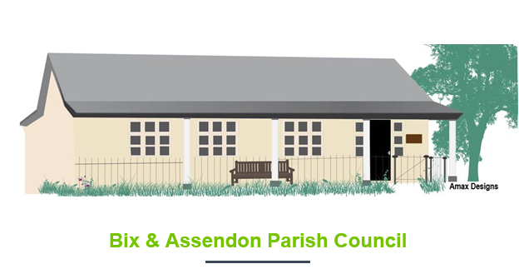
Spring Litter Pick Sunday 12th April 2026

Take pride in your village and help by joining us on
to litter pick and to clean some of the local road signs.

We will be starting at 10am in the Assendons and Bix from three positions across the parish:
Middle Assendon – 10am meet at the triangle opposite the Rainbow Pub
Lower Assendon – 10am meet on the bridge triangle by the lane up to Fawley
Bix – 10am meet in the Village Hall Car Park
Equipment, pickers and fluorescent jackets, will be provided but we recommend wearing gloves to protect your hands and bright clothing so that you can be seen.
We would love to have an idea of numbers if you could let us know on kj_duthie@hotmail.com.
We hope to see you there!
Bix and Assendon Parish Council

